Practical 2 : Sending Secret Message Using CMD & Notepad

Aim
To hide a secret message inside an image file using Command Prompt without using any programming language.

Theory
Steganography is a technique of hiding secret data inside another file such as an image, audio, or video.
In this method:
- We combine an image file and a text file
- The message is hidden inside the image file
- The image appears normal but contains hidden data
This method is based on file concatenation (joining files).

Requirements
- Command Prompt (CMD)
- Notepad
- Any image file (e.g., image.jpg)

Files Used
- Image File: image.jpg
- Text File: secret.txt

Step-by-Step Procedure

Step 1: Create Secret Message File
- Open Notepad
- Type your secret message
Example:
This is a secret message
- Save file as: secret.txt
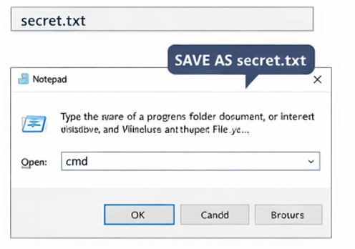

Step 2: Keep Image Ready
Take any image and save it as: image.jpg
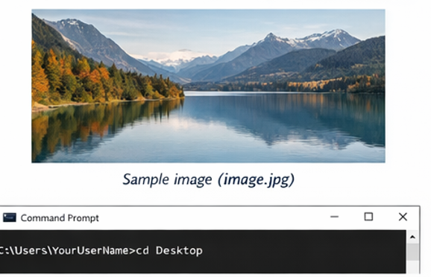

Step 3: Open Command Prompt
- Press Win + R and typ e CMD to open command prompt and Press Enter
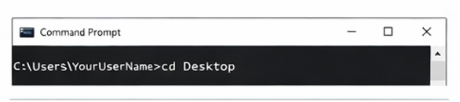

Step 4: Go to Folder Location
Example: cd Desktop
(Go to the folder where both files are saved)

Step 5: Merge Image and Text File
Type this command:
copy /b image.jpg + secret.txt output.jpg
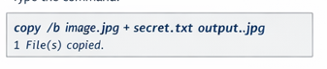

Explanation
- /b → Binary mode
- + → Combines files
- output.jpg → Final image with hidden message

Output
After running command:
1 file(s) copied.
A new file will be created:
output.jpg

Result Observation
- output.jpg looks exactly like original image
- But it contains hidden message
The output image appears unchanged but secretly contains the embedded message.

Extracting the Hidden Message

Using Notepad
- Right-click output.jpg
- Open with Notepad
👉 Scroll to bottom
👉 You will see:
This is a secret message

